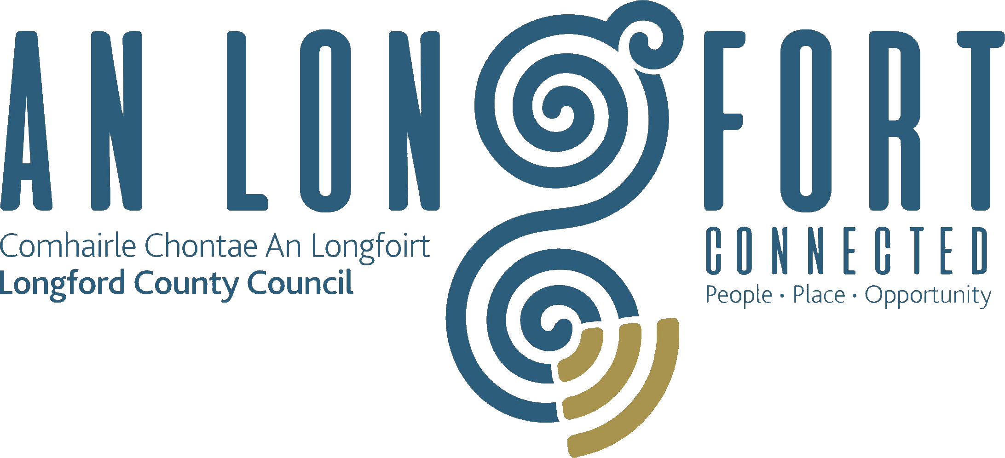

BALLYMAHON MUNICIPAL DISTRICT

Minutes of Meeting of Ballymahon Municipal District held in Ballymahon Community Library on Thursday, 1st October 2018 at 4.30 p.m.

CATHAOIRLEACH: Councillor Paul Ross

MEMBERS PRESENT: Councillors – Mick Cahill, Gerard Farrell,
Colm Murray and Pat O’Toole.

APOLOGIES: Councillor – Mark Casey
Ms. Anne Lee, Meeting Administrator

IN ATTENDANCE: Ms. Barbara Heslin, Director of Services.
Ms. Linda Higgins, Administrative Officer
Mr. Paul Newell, Senior Executive Engineer.

MEETINGS
ADMINISTRATOR:

VOTE OF SYMPATHY.

Cathaoirleach P. Ross, on behalf of the Members of Ballymahon Municipal District, extended sympathy to Councillor Mark Casey and his family on the death of his wife, Bernadette. A minute’s silence was observed at the start of the meeting.

ADOPTION OF MINUTES.

On the proposal of Councillor C. Murray seconded by Councillor M. Cahill, the Minutes of Committee Meeting of Ballymahon Municipal District held on the 26th July 2018, as circulated, were confirmed and adopted.

On the proposal of Councillor G. Farrell seconded by Councillor P. O'Toole, the Minutes of Meeting of Ballymahon Municipal District held on the 26th July 2018, as circulated, were confirmed and adopted.

MATTERS ARISING FROM MINUTES.

POLICY – CEMETERY EXTENSIONS/PURCHASES.
FUNDING TO CEMETERY COMMITTEES.

Linda Higgins provided the Members with an update from the Infrastructural and Environmental Services Strategic Policy Committee meeting which was held on 21st September in relation to recommendations to the SPC from the Ballymahon Municipal District regarding Cemetery Extensions/Purchase and Funding to Cemetery Committees –

- If no existing policy in place a new policy regarding Cemetery Extensions/Purchases should be prepared, with MD input. The members also requested that any existing policy should be circulated to the MD Members.
The current Councils’ policy in relation to Cemetery Extensions was adopted by the County Council in April 2011 and states as follows;
“The Council will no longer make any contribution relating to the purchase of land for the development of either a new cemetery or an extension to an existing cemetery. The acquisition of any land that is required to facilitate the development of a new cemetery or an extension to an existing cemetery will be the responsibility of either the parish concerned or the local cemetery committee. The Council can no longer fully fund the cost of providing cemeteries and extensions to cemeteries. However, the Council will provide a contribution that is equivalent to 25% of the cost of developing an agreed number of cemetery plots subject to the provision of audited accounts and the availability of funding. It was also agreed that any group which is planning to acquire land for cemetery purposes should liaise with the Council in advance of completing a land purchase. By doing so the group would facilitate the provision to it by the Council of an indication of the level of funding that could reasonably be expected in relation to any individual proposal that was under consideration.”

The LCC Environment SPC proposes to review its policies in relation to Cemeteries in the coming months.

- There should be a defined closing date for the receipt of applications for funding.

An application form for the Cemetery Support Scheme was distributed by the Environment Section to all Cemetery Committees who usually apply for this grant, informing them of a closing date of 30th September. However, realistically, works would be ongoing in September/October and applications are often received and processed in October/November each year.

- A standard application form for Cemetery Funding should be available in the three Municipal Districts.

Application forms for the Cemetery Support Scheme have been in place since 2005.

- The final decision regarding Cemetery Funding should be made by the Municipal District members, as the funding is part of the approved G.M.A.
Grant applications made to the Environment Section for the Cemetery Support Scheme (for day-to-day maintenance) are processed on submission of a completed application form and appropriate receipts and a list of proposed awards can be made available to the MD for approval prior to payment.

Cemetery Funding approved by the Municipal District, other than the Cemetery Support Scheme, shall be processed, as follows:-
- Where the cemetery is Council-owned, Longford County Council Environment Section will arrange and supervise the works to be carried out and process the necessary payment(s), within the funding level approved.
- Where the cemetery is not Council-owned, the relevant Cemetery Committee will be subject to same terms and conditions of the Community Grants Support Scheme, i.e.verification that works were satisfactorily completed and submission of appropriate invoices or receipts.

It was agreed by the Members of the Infrastructural and Environmental Services Strategic Policy Committee that the current Policies in relation to Cemeteries be reviewed and submitted to the SPC for consideration.

The Members of Ballymahon Municipal District agreed that they will make a joint submission to the SPC regarding small cemetery grants, closing date for receipt of applications and approval process.

MANAGEMENT REPORT.

The Management Report, as circulated, was noted.

TAKING IN CHARGE OF “CORNCRAKE MEADOWS”, ABBEYSHRULE,
CO. LONGFORD.

On the proposal of Councillor Mick Cahill seconded by Councillor Colm Murray, it was unanimously agreed to the taking in charge of “Corncrake Meadows”, Abbeyshrule,
Co. Longford, as circulated.

PART 8 REPORT - FOOTBRIDGE OVER RIVER INNY.

On the proposal of Councillor Pat O'Toole seconded by Councillor Mick Cahill, it was unanimously agreed to the adoption of the Part 8 Report (Planning and Development Act 2000 (as amended) and Planning and Development Regulations 2001) (as amended) in respect of proposal to carry out a development referred to as – construction of a footbridge over the River Inny at Clooneen and Newcastle, Ballymahon, Co. Longford.

APPLICATIONS FOR FUNDING UNDER THE 2018 COMMUNITY GRANT
SUPPORT SCHEME.

On the proposal of Councillor Colm Murray seconded by Councillor Pat O'Toole the additional applications which were received under the Community Support Scheme and recommendations were noted and agreed.

NOTICES OF MOTIONS.

Houses in Foxhall Cresent, Legan

The following Notice of Motion was proposed by Councillor P. Ross and seconded by
Councillor G. Farrell -

"That all the houses in Foxhall Cresent, Legan be retrofitted with new energy efficient windows."

The Housing section has confirmed that, at present, there is no funding announced for energy efficiency retro fitting phase 2. Estates will be surveyed and ranked when funding is made available for upgrade works. Survey/works will be prioritised on oldest estates first.

Maintenance of Roundabouts and Grass Verges, Edgeworthstown.

The following Notice of Motion was proposed by Councillor P. Ross and seconded by
Councillor M. Cahill -

"That Longford County Council put a policy in place to maintain the roundabouts and grass verges on the Edgeworthstown bypass."

Paul Newell confirmed that he has already engaged with Edgeworthstown Tidy Towns. The proposal by Councillor Ross will be considered as part of a review of the quantity and quality of grass cutting on the Edgeworthstown bypass with the Tidy Towns.

Traffic Lights, Pound Street, Edgeworthstown.

The following Notice of Motion was proposed by Councillor P. Ross and seconded by
Councillor M. Cahill -

"That Longford County Council conduct a review of the traffic lights at Pound Street, Edgeworthstown with a view to removing them and replacing with a more suitable junction layout."

Paul Newell confirmed that an assessment is underway and pending the result of this assessment Longford County Council will consider what the amendments to the junction may be necessary or appropriate.

Extension of Ballymahon Town Sewerage Scheme.

The following Notice of Motion was proposed by Councillor P. O’Toole and seconded by
Councillor M. Cahill -

“In light of the requests to upgrade the Ballymahon Town Sewerage System, I call on Longford County Council to extend the system to include the following townlands - Terlicken, Moigh, Cartronbouy and Moneyfad."

The Infrastructural section confirmed that Irish Water is the appropriate Water Service Authority with regard to future waste water treatment plant and sewer network developments. The current indications in the Irish Water draft Investment Plan, which is subject to the approval of the Commission for the Regulation of Utilities (CRU), is that Ballymahon waste water treatment plant is proposed for an upgrade in the period 2020 – 2024. With the approval of the Ballymahon Municipal District a letter can be written to Irish Water seeking the inclusion with the proposed plant upgrade of a network extension of the sewerage system to the townlands of Terlicken, Moigh, Cartronbouy and Moneyfad.

On the proposal of Councillor Pat O'Toole seconded by Councillor Mick Cahill it was agreed that Longford County Council write to Irish Water requesting that the townlands of Terlicken, Moigh, Cartronbouy and Moneyfad be included in their expansion plans for Ballymahon Town Sewerage System.

CORRESPONDENCE – circulated.

Correspondence dated 7th August 2018 received from the Department of Employment Affairs and Social Protection regarding Community Welfare Services in Lanesboro.

Correspondence dated 14th August 2018 received from Irish Water regarding upgrade of sewerage treatment and the wastewater plant in Ballymahon.

Correspondence received from the Department of Business, Enterprise and Innovation regarding review of the Casual Trading Act 1995 and the Occasional Trading Act 1979.
The Members requested that a copy of the correspondence be circulated to the traders associations in Lanesboro, Edgeworthstown and Ballymahon for their information.

GMA MEETING.

25th October was the proposed date for the GMA and Roads Programme meeting. Councillor Colm Murray informed the meeting that this date clashes with the AILG Conference. An alternative date will be notified to the Members.

LOCATION OF MEETINGS.

Councillor Paul Ross informed the Members that he hoped to schedule meetings in the New Year in Lanesboro, Corlea and Edgeworthstown.

TASTE OF LAKELANDS.

Councillor Gerard Farrell reminded the members of the Taste of Lakelands Festival scheduled for 6th and 7th October. He also told the meeting that Lough Ree Distillery will be launching their new gin, Sling Shot, on Friday 5th October. He also acknowledged the support received from Longford County Council and the Local Enterprise Office.

This concluded the business of the meeting.

Signed: _______________
Anne Lee,
Meetings Administrator.

Confirmed and adopted at Ballymahon Municipal District Meeting held on the
22nd November, 2018.

Signed: _______________
Cathaoirleach.

